**Additional information on the demographic component of the mathematical model**

As explained in the main article, the demographic parameters were dependent on the day of the year (day 1 = 1 January) and the age of an individual (in days). They were optimized in order to simulate realistic population density fluctuations and age distributions, while being also biologically realistic. The population densities were compared to the longitudinal field data of the CMR experiment. The age distributions were compared to the field data of Leirs (1994), who measured the eye lens weight of M. natalensis throughout the year as a proxy of the animals’ age (Fig S1).

Individuals live for an exponentially distributed amount of time depending on the mortality parameter (μ), which was modelled by the following equations:

μ (day < 15 & age < 366) = 0.004 lifespan-1

μ (14 < day < 74 & age < 366) = 0.013 lifespan-1

μ (74 < day < 120 & age < 366) = 0.0064 lifespan-1

μ (day >120 & age < 366) = 0.004 lifespan-1

μ (age > 365) = 0.09 lifespan-1.

As an example, an individual of 100 days old on January 1 had a probability of 0.4% to die before the next time step, which is one day later. Given that animals older than one year did not occur in the CMR dataset, we increased the mortality rate once individuals reached that age in the model.

The following equations model the birth rate of M. natalensis (Φ), which was also a function of time and age:

Φ (day < 111 or day > 329 & age > 120) = 0 [births/(individual*time interval)]

Φ (110 < day < 256 & age > 120) = 0.0012 * (day – 110) [births/(individual*time interval)]

Φ (255 < day < 330 & age > 120) = 0.16 * (day – 255) [births/(individual*time interval)]

Φ (age < 121) = 0 [births/(individual*time interval)].

We assumed that individuals younger than 120 days could not give birth. Furthermore, Φ was corrected each year by a factor in order to simulate variation in peak densities similar to the densities observed in the field data.

**Supplementary figures**

C:\Users\jmarien\Desktop\histogram age3.tif

**Fig S1:** Age distribution (days) of *M. natalensis* in the model simulations per month. Age distributions were simulated as closely as possible to field data (Leirs 1994).



**Fig. S2:** Fit of mathematical models of MORV transmission in a population of *M. natalensis*. *Left*: Models with (red) and without (blue) vertical transmission and density-dependent horizontal transmission. *Middle:*  Models with density- (red) and frequency- (blue) dependent horizontal and vertical transmission. *Right*: Models with density-dependent horizontal and vertical transmission with constant (red) and season-specific (blue) *β*. Red and blue dotted lines indicate 95% confidence intervals of the model results. Black solid lines indicate 95% confidence intervals on the seasonal pattern of the field data.

**C:\Users\jmarien\Desktop\Age- ab presence.tif**

**Fig S3:**  Correlations between body weight of *Mastomys natalensis* (as a proxy for age) and probability of being Morogoro virus-antibody positive at different periods of the year (June-August, September-November, December, February and March-May). The figure suggests that both season (density) and age are predictors of antibody presence in *M. natalensis*.

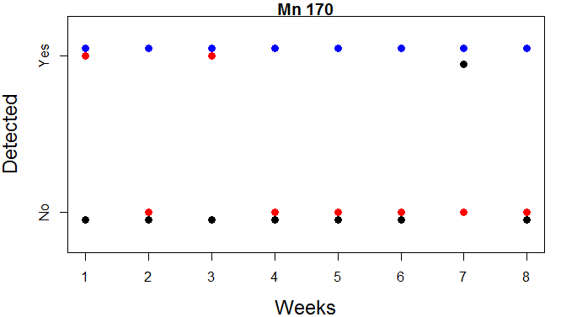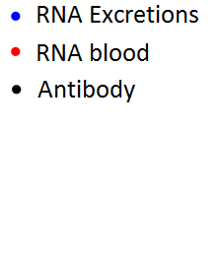

**Fig S4**: Individual 170: MORV RNA was detected in excretions (saliva and urine) every week, in blood on week one and three, and in the kidneys (week eight). Antibodies were only detected on week seven.

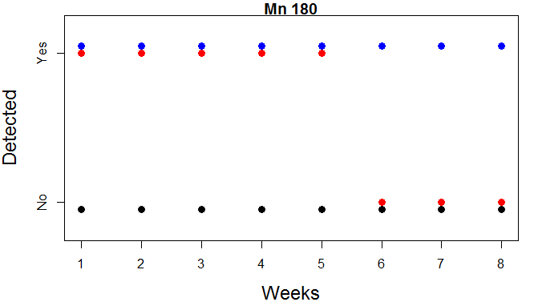

**Fig S5**: Individual 180: MORV RNA was detected in excretions (saliva and urine) every week, in blood the first five weeks, and in the kidneys (week eight). Antibodies were not detected.

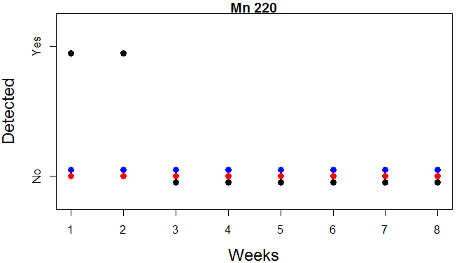

**Fig S6:** individual 220: MORV RNA was detected in the kidneys only (week eight). Antibodies were detected in week one and two, suggesting that this individual became infected before it was captured, removed the virus from blood and excretions, but retained the virus in its organs.